**Assignment 2 :**

Name : Ruchita Kamble

Div. : CS -B

Roll no. : 50

PRN : 12210178

1)Arithmetic operations

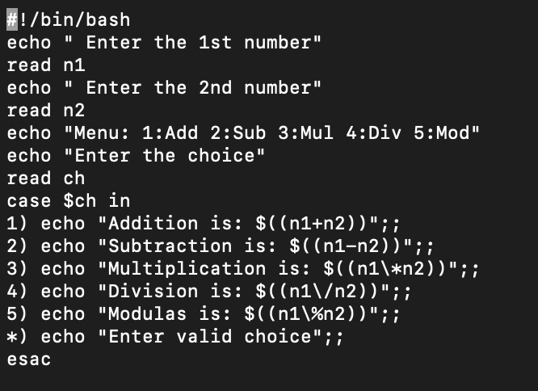

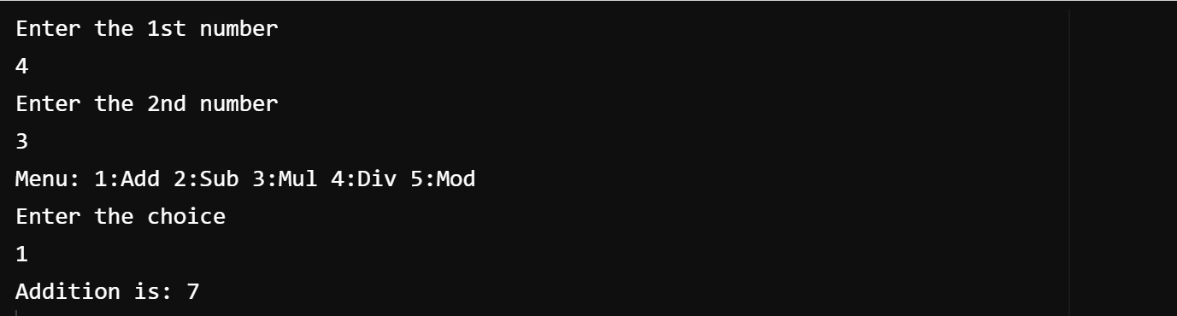

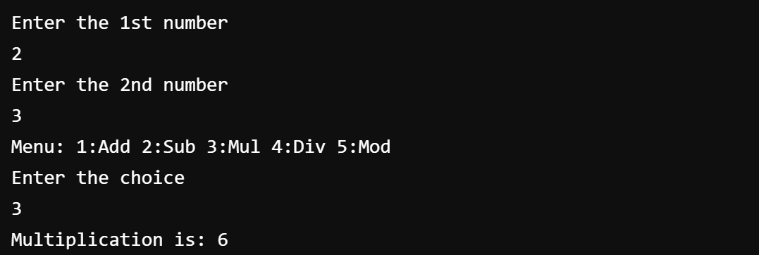

2) If-else statement

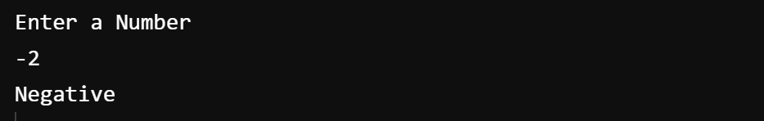

3) Write a program to calculate factorial of given number

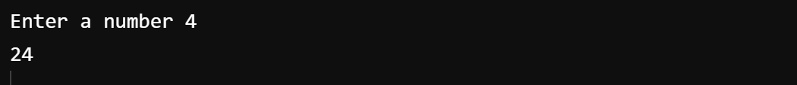

4) Loop(for loop)

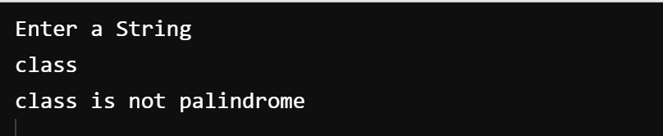

5) To check and count occurences of substring in given string by using CLA.

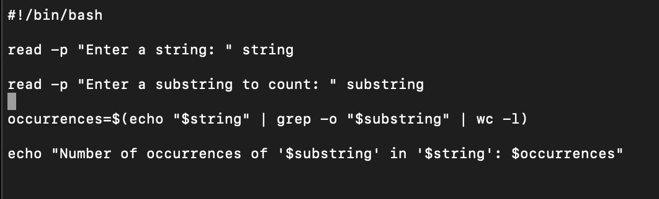



6) Function(if, do-while)

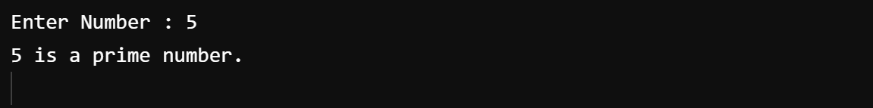

7) Array

#! /bin/bash

array=(welcome to vit)

echo ${array[@]}

echo ${array[*]}

echo ${array[@]:0}

echo ${array[*]:0}

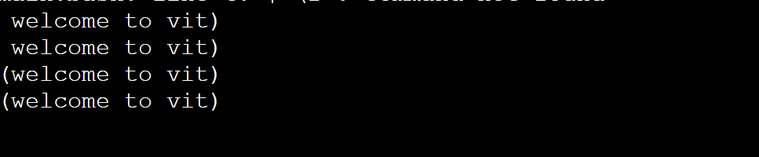

8) To print reverse of given number.

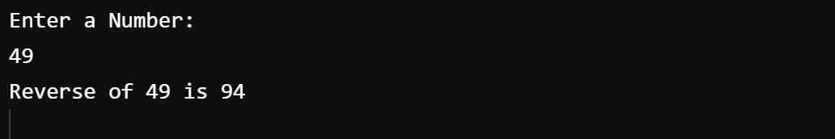

9) strings (length concatenation substring compare)

Code :

#!/bin/bash

read -p "Enter first string: " VAR1

read -p "Enter second string: " VAR2

if [[ "$VAR1" == "$VAR2" ]]; then

echo "Strings are equal."

else

echo "Strings are not equal."

Fi

Output :

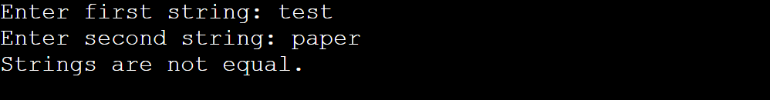

10)string

